Positions available | APS4 Assistant Hostel Manager  APS4 Roving Assistant Hostel Manager  APS5 Hostel Manager  APS5 Roving Hostel Manager
location | Nationwide excluding ACT and TAS
vacancy type | Ongoing, non-ongoing and casual – Full-time/Part-time
salary range | APS4 Level: $79,125 - $86,246 + 15.4% Superannuation  APS5 Level: $88,834 - $96,839 + 15.4% Superannuation

March 2026
Contact: recuitment@ahl.gov.au

welcome to AHL
Thank you for your interest in working with Aboriginal Hostels Limited (AHL). AHL is a not-for-profit Commonwealth company dedicated to providing culturally safe and affordable accommodation for First Nations people who need to be away from home to access services and economic opportunities. We provide a bed, as well as 3 meals a day, to around 17,000 First Nations people each year.
AHL’s vision is to improve the quality of life and economic opportunities for First Nations people. Since 1973, AHL has been committed to improving the quality of life and economic opportunities for First Nations people through a national network of over 40 hostels across Australia.
Working at AHL means being part of an organisation that makes a difference in First Nations community every day. Our employees play an important role in creating a safe, respectful and supportive home away from home that is culturally safe and affordable.
Our people are at the heart of everything that we do. We are committed to providing a culturally safe workplace that values professionalism, respect, openness, understanding and dedication.

why join us?
This is an opportunity to continue the over 50-year legacy of AHL and have a real and lasting impact on the lives of First Nations people. You will join a team that encourages collaboration to achieve outcomes, problem solving, continuous improvement and requires a high level of integrity. We promote a supportive working environment, with a strong commitment to professional growth, inclusion, and public service values.
By working with AHL you will have access to meaningful work that contributes to positive outcomes for First Nations people. AHL offers supportive, culturally safe, team environments along with training and development to help you succeed in your role. As you progress in your AHL career you can also have opportunities for leadership career development opportunities, if this is something that you would like.
As a Public Benevolent Institution (or “Not-For-Profit”), we offer significant benefits through salary packaging, which allows our employees to use pre-tax dollars for expenses like mortgage, rent, and living expenses. This is in addition to the usual salary packaging availability for vehicles and laptops and is not ordinarily available in other APS agencies. Utilising the full $15,900 cap per FBT year (April to March), results in substantial tax savings, increased take-home pay, and greater financial flexibility.

position included in this recruitment round
This recruitment process is being used to fill current vacancies and may establish a merit pool, giving you the opportunity to be considered for roles over the next 18 months. As positions become available, suitable candidates may be contacted based on their nominated locations and role preferences
This bulk round includes multiple APS4 and APS5 positions across Australia.
APS4 roles focus on supporting the day-to-day operations of the hostel and the wellbeing of residents. These roles follow established procedures and provide practical support to ensure a safe and structured hostel environment. APS5 roles are responsible for managing hostel operations and supporting staff. These roles involve a higher level of responsibility and decision making.

APS4 Assistant Hostel Manager and Roving Assistant Hostel Manager
Typical responsibilities for an APS4 Assistant Hostel Manager may include:
- supporting daily hostel operations and helping ensure services run smoothly
- providing guidance and support to hostel staff
- helping create a safe, welcoming and culturally appropriate environment for residents
- supporting residents to access services and resources that promote health, wellbeing and independence
- managing guest bookings, payments and related administrative tasks
- assisting with timesheets, facility checks, food service requirements and general hostel duties where required
- helping resolve resident or guest concerns in a professional and respectful way
- supporting cultural activities and events, including days of significance for First Nations peoples
- maintaining privacy and confidentiality of resident and staff information
- always promoting the safety and wellbeing of children and young people in line with AHL’s child safeguarding requirements
- supporting safe work practices, emergency procedures and reporting of hazards or incidents.
Roving Assistant Hostel Managers perform the same duties across multiple hostels and may travel between locations.

APS5 Hostel Manager and Roving Hostel Manager
Typical responsibilities for an APS5 Hostel Manager/Roving Hostel Manager may include:
- leading the day-to-day operations of the hostel
- providing leadership, direction and support to staff
- ensuring services are delivered in line with AHL policies, procedures and operational requirements
- creating a safe, welcoming and culturally appropriate environment for residents
- supporting residents to access services and resources that promote health, wellbeing and independence
- managing bookings, payments, budgets, rosters and other operational requirements
- overseeing food service, facility checks, maintenance reporting and general service delivery
- supporting staff performance, development, training and induction
- building positive relationships with stakeholders, including local Aboriginal and Torres Strait Islander organisations
- supporting cultural activities and events, including days of significance for First Nations peoples
- always promoting the safety and wellbeing of children and young people in line with AHL’s child safeguarding requirements
- ensuring WHS, incident reporting and emergency procedures are followed.
Roving Hostel Managers perform the same duties across multiple hostels and may travel between locations.

what we are looking for
We are looking for people who are committed to supporting First Nations peoples and contributing to a safe, respectful and culturally appropriate environment.
You do not need previous APS experience to apply. We value candidates who bring relevant experience, strong values and a genuine interest in supporting others.
Strong candidates will demonstrate:
- understanding of, or willingness to learn about, First Nations cultures and ability to communicate respectfully and sensitively with First Nations peoples
- commitment to providing culturally safe services and environments
ability to build positive relationships with residents, students, colleagues and stakeholders and respond calmly and appropriately to challenges
- ability to work effectively as part of a team and demonstrate clear and respectful communication
- ability to follow policies and procedures and a commitment to maintaining safe environments for residents, students and staff
- ability to manage competing priorities and show reliability, professionalism and good judgement
- commitment to AHL’s child safeguarding and work health and safety requirements
- proficiency in the Microsoft Office suite.
For APS5 roles we are also looking for candidates who can also:
- provide leadership and guidance to staff and support team performance and development
- contribute to continuous improvement in hostel operations
- confidently make decisions in line with policies and operational requirements.
We encourage applications from people with diverse backgrounds and experiences, including those new to the APS or working in a hospitality or hostel environment.
If you are passionate about supporting First Nations people, we encourage you to apply.

Locations and Employment Arrangements
Positions are available in multiple locations across Australia. In the application form, you will be asked to nominate the location/s that you are interested in working in. Locations include:
Sydney | Newcastle | Tamworth | Dubbo
Melbourne | Alice Springs | Katherine | Darwin
Tennant Creek | Nhulunbuy | Brisbane | Thursday Island
Mackay | Cairns | Townsville | Mount Isa
Rockhampton | Adelaide | Perth | Broome
South Hedland | Kalgoorlie

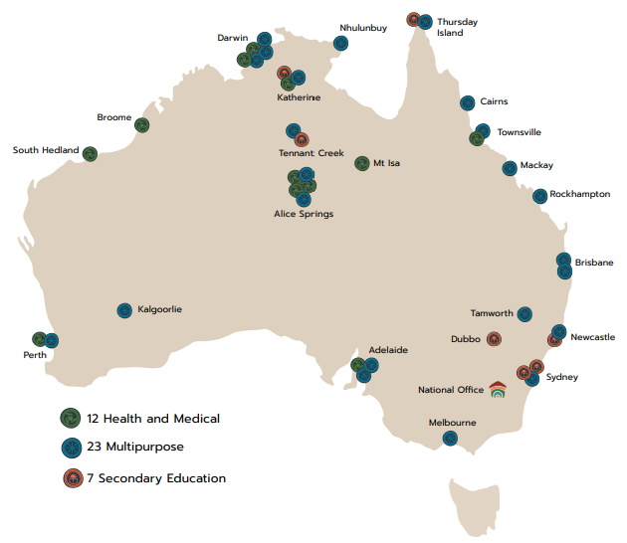

Employment types include:
- Ongoing positions
- Non-Ongoing positions
- Casual opportunities
- Full Time and Part Time arrangements
This recruitment process is being used to fill current vacancies and may establish a merit pool, giving you the opportunity to be considered for roles over the next 18 months. As positions become available, suitable candidates may be contacted based on their nominated locations and role preferences.

Recruitment Timeline

Qualifications and Experience
The following qualifications are required for these roles. If you do not currently hold them, AHL can support you to obtain them within the required timeframe
- First Aid Certificate
- Emergency Warden Training
- Food Safety Supervisor Certificate
These qualifications can be obtained within the first six months of employment where required, with training provided by AHL.

Fitness for work
These roles involve a hands-on working environment. You will need to be able to:
- Walk and stand for extended periods
- Lift and carry items where required
- Remain active throughout the working day
A reasonable level of physical fitness is required to safely perform the duties of the role.

Recruitment Initiatives
The RecruitAbility scheme applies to this vacancy. Under the RecruitAbility you will be invited to participate in further assessment activity for the vacancy if you choose to apply under RecruitAbility, declare you have a disability, and meet the minimum requirements for the position. For more information on the RecruitAbility scheme, please see link: APSC Recruitability scheme guide applicants.

Eligibility
To be eligible to apply, applicants must be Australian Citizens or have already lodged an application for Australian Citizenship.
Successful applicants will be required to:
- provide an Australian Citizenship document (e.g. birth certificate or passport)
- hold and maintain a Working with Children Check in your relevant state
- undergo a Satisfactory National Criminal History Check, and
- meet the Fitness for Duty requirements.
For new APS employees, a six-month probationary period will apply.

How to apply
- Complete the Application Form, including the 1-page pitch, available on our website www.ahl.gov.au/work
- Email your completed Application Form and current resume to jobs@ahl.gov.au before 11:59pm AEST on 19 April 2026.
- Include your name and the job reference (VN-0768374) in the subject of your email.
You may apply for multiple roles and locations. If you select more than one option, you will be considered for all roles and locations you have indicated in your application.
If you are unsure whether you meet every requirement, we still encourage you to apply. We value diverse experience and a genuine interest in supporting First Nations communities.

Tips for preparing your application
Your pitch is your opportunity to tell us why you are the best person for the role. You may want to tell us about:
- why you are interested in working at AHL
- experience supporting people, students or communities
- examples of teamwork
- examples of problem solving
- leadership or supervisory experience
- any relevant qualifications or training.
For more advice and resources to help you with your application, you can access information on the Australian Public Service Commission website at 3. Applying for an APS job: cracking the code | Australian Public Service Commission

